Lab 4 Final Task:

Customer Table (For filtering by city, name)

|  |  |  |  |  |
| --- | --- | --- | --- | --- |
| customer id | name | email | phone | address |
| 1 | Alice Johnson | [alice@gmail.com](mailto:alice@gmail.com) | 9876543210 | New York |
| 2 | Bob Smith | [bob@yahoo.com](mailto:bob@yahoo.com) | 9123456789 | Los Angeles |
| 3 | Charlie Brown | [charlie@outlook.com](mailto:charlie@outlook.com) | 9998887776 | Chicago |
| 4 | David Miller | [david@gmail.com](mailto:david@gmail.com) | 8765432109 | Miami |
| 5 | Amy Adams | [amy@hotmail.com](mailto:amy@hotmail.com) | 7654321098 | New York |

Product Table (For filtering by category, price, and stock quantity)

|  |  |  |  |  |
| --- | --- | --- | --- | --- |
| product id | name | category | price | stock quantity |
| 1 | Milk | Dairy | 2.50 | 50 |
| 2 | Bread | Bakery | 1.80 | 30 |
| 3 | Eggs | Dairy | 3.20 | 40 |
| 4 | Chicken | Meat | 7.50 | 20 |
| 5 | Apples | Fruit | 1.20 | 60 |
| 6 | Croissant | Bakery | 2.50 | 25 |

Employee Table (For filtering by hire date, salary)

|  |  |  |  |  |
| --- | --- | --- | --- | --- |
| employee id | name | role | salary | hire date |
| 1 | Michael Scott | Manager | 75000.00 | 2020-05-10 |
| 2 | Jim Halpert | Cashier | 30000.00 | 2021-08-15 |
| 3 | Pam Beesly | Sales Associate | 28000.00 | 2022-02-20 |
| 4 | Dwight Schrute | Supervisor | 50000.00 | 2019-11-30 |

|  |  |  |  |  |
| --- | --- | --- | --- | --- |
| 5 | Kevin Malone | Cashier | 29000.00 | 2023-03-10 |

OrderDetails Table (For filtering orders based on date)

|  |  |  |  |
| --- | --- | --- | --- |
| order id | customer id | order date | total amount |
| 1 |  | 2024-01-10 | 10.50 |
| 2 | 2 | 2024-01-12 | 15.20 |
| 3 | 3 | 2024-02-01 | 20.80 |
| 4 | 4 | 2024-02-05 | 30.00 |
| 5 | 5 | 2024-02-10 | 25.50 |

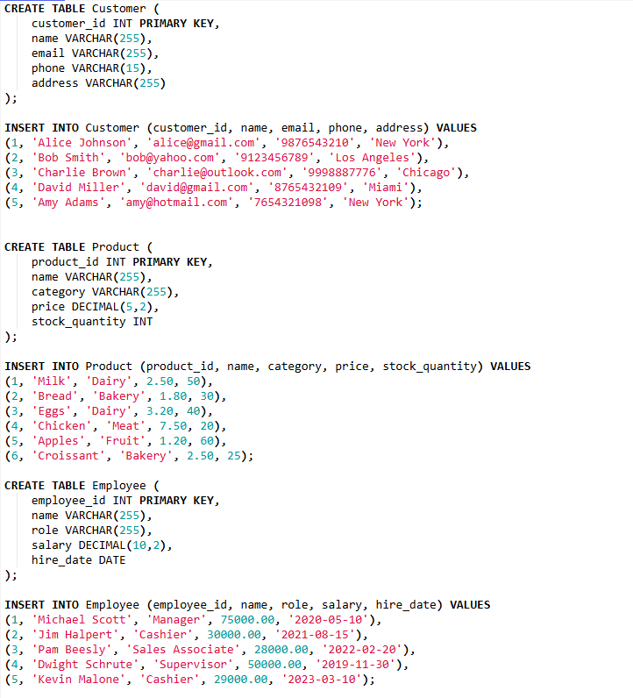 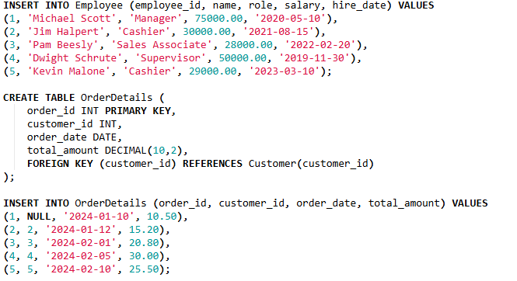

1. Write the queries to generate above tables to use as the sample for given below queries.
2. Find all customers **from** New **York or** Los Angeles.

SELECT * FROM Customer WHERE address IN ('New York', 'Los Angeles');

+-------------+---------------+-----------------+------------+-------------+

| customer_id | name | email | phone | address |

+-------------+---------------+-----------------+------------+-------------+

| 1 | Alice Johnson | alice@gmail.com | 9876543210 | New York |

| 2 | Bob Smith | bob@yahoo.com | 9123456789 | Los Angeles |

| 5 | Amy Adams | amy@hotmail.com | 7654321098 | New York |

+-------------+---------------+-----------------+------------+-------------+

1. Retrieve products that are **Dairy or Bakery items.**

SELECT * FROM Product WHERE category IN ('Dairy', 'Bakery');

+------------+-----------+----------+-------+----------------+

| product_id | name | category | price | stock_quantity |

+------------+-----------+----------+-------+----------------+

| 1 | Milk | Dairy | 2.50 | 50 |

| 2 | Bread | Bakery | 1.80 | 30 |

| 3 | Eggs | Dairy | 3.20 | 40 |

| 6 | Croissant | Bakery | 2.50 | 25 |

+------------+-----------+----------+-------+----------------+

1. Find employees **hired** between **2021 and 2023.**

SELECT * FROM Employee WHERE hire_date BETWEEN '2021-01-01' AND '2023-12-31';

+-------------+--------------+-----------------+----------+------------+

| employee_id | name | role | salary | hire_date |

+-------------+--------------+-----------------+----------+------------+

| 2 | Jim Halpert | Cashier | 30000.00 | 2021-08-15 |

| 3 | Pam Beesly | Sales Associate | 28000.00 | 2022-02-20 |

| 5 | Kevin Malone | Cashier | 29000.00 | 2023-03-10 |

+-------------+--------------+-----------------+----------+------------+

1. List customers whose names start with ‘A’.

SELECT * FROM Customer WHERE name LIKE 'A%';

+-------------+---------------+-----------------+------------+----------+

| customer_id | name | email | phone | address |

+-------------+---------------+-----------------+------------+----------+

| 1 | Alice Johnson | alice@gmail.com | 9876543210 | New York |

| 5 | Amy Adams | amy@hotmail.com | 7654321098 | New York |

+-------------+---------------+-----------------+------------+----------+

1. Retrieve orders placed in **February 2024.**

SELECT * FROM OrderDetails WHERE order_date BETWEEN '2024-02-01' AND '2024-02-29';

+----------+-------------+------------+--------------+

| order_id | customer_id | order_date | total_amount |

+----------+-------------+------------+--------------+

| 3 | 3 | 2024-02-01 | 20.80 |

| 4 | 4 | 2024-02-05 | 30.00 |

| 5 | 5 | 2024-02-10 | 25.50 |

+----------+-------------+------------+--------------+

1. Count the total number of customers.

SELECT COUNT(*) AS total_customers FROM Customer;

+-----------------+

| total_customers |

+-----------------+

| 5 |

+-----------------+

1. Find the average product price.

SELECT AVG(price) AS average_price FROM Product;

+---------------+

| average_price |

+---------------+

| 3.116667 |

+---------------+

1. Get the **maximum** salary of employees.

SELECT MAX(salary) AS max_salary FROM Employee;

+------------+

| max_salary |

+------------+

| 75000.00 |

+------------+

1. Retrieve the total revenue from orders.

SELECT SUM(total_amount) AS total_revenue FROM OrderDetails;

+---------------+

| total_revenue |

+---------------+

| 102.00 |

+---------------+

1. Find the **minimum** stock **quantity** available.

SELECT MIN(stock_quantity) AS min_stock_quantity FROM Product;

+--------------------+

| min_stock_quantity |

+--------------------+

| 20 |

+--------------------+